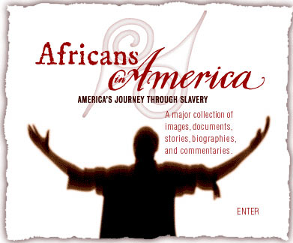
Vocabulary
Directions: One mark for each of the following definitions or explanations of the words or events below. Please write in complete sentences.

Abolitionist Movement

Civil War

Compromise of 1850

Constitution

Dred Scott Decision

Emancipation Proclamation

Fugitive Slave Law (1850)

Westward Expansion

Notable People
Directions: One mark for an explanation of the impact each of the following people had on the slavery movement. Please write in complete sentences.

Charles Ball

John Brown http://www.pbs.org/wgbh/aia/part4/4p1550.html

Anthony Burns http://www.pbs.org/wgbh/aia/part4/4p2915.html

Pierce Butler http://www.pbs.org/wgbh/aia/part4/4p1569.html

Frederick Douglass http://www.pbs.org/wgbh/aia/part4/4p1539.html

William Lloyd Garrison http://www.pbs.org/wgbh/aia/part4/4p1561.html

Harriet Jacobs http://www.pbs.org/wgbh/aia/part4/4p2923.html

Fanny Kemble http://www.pbs.org/wgbh/aia/part4/4p1569.html

Nat Turner

David Walker http://www.pbs.org/wgbh/aia/part4/4p2930.html

Prediscussion
Answer the following questions before we watch the film in class. Please write in complete sentences.

- What impact do you think slavery had on white people who didn't own slaves? On those who did own slaves? Why might someone who wasn't a slave owner support slavery? Why might someone be opposed to the spread of slavery, but not opposed to slavery itself? 4 marks

- What influence could a speech, pamphlet, or newspaper have on those for or against slavery? Why might reading or writing be considered "dangerous" by pro-slavery proponents? 2 marks

Exploring Primary Sources
Why did abolitionists find so much resistance to their cause in the North? Follow the links below and read the primary source documents below. In each document consider the following: Who is speaking? To whom is he speaking? What is the intended audience? How do you think they responded? Use the information that you read and gather to answer the question below.
- David Walker's Appeal
- Henry Highland Garnet's "Call to Rebellion"
- Frederick Douglass' "The Meaning of July Fourth..."
- Anthony Burns's account of his capture
- Harriet Jacobs' Incidents in the Life of a Slave Girl
- Samuel J. May, Some Recollections of our Anti-Slavery Conflict
- James Henry Hammond's speech

Historian Herbert Aptheker identifies three major schools of thought among abolitionists:
- Moral suasion [persuasion] as the only proper and effective instrument for change
- Moral suasion supported by political action
- Resistance through direct, physical, militant action.*
- Who was involved in the abolitionist movement? In what ways do you think abolitionists differed on the strategies and goals of their movement? Why do you think they disagreed? 3 marks

After Watching
Directions: After watching the video in class answer the following questions. Please answer in complete sentences.
1
What were some of the methods used by abolitionists? How did women contribute to the movement? 2 marks

2
In addition to the abolition of slavery, in what other ways did abolitionists seek to change America? Why did some view their activities as a threat to the social order? 2 marks

3
In what ways could Walker's Appeal reach the South? Once there, how could it be distributed? Who do you think distributed it? What consequences might a person in possession of Walker's Appeal face if caught? 4 marks

4
After Walker's Appeal appeared in the South, the governors of Georgia and North Carolina called secret sessions of the state legislatures to decide how to deal with the threat. Why do you think it posed such a threat?

